Chapter 18 – Networking

Outline
18.1 Introduction
18.2 Manipulating URLs
18.3 Reading a File on a Web Server
18.4 Establishing a Simple Server Using Stream Sockets
18.5 Establishing a Simple Client Using Stream Sockets
18.6 Client/Server Interaction with Stream Socket Connections
18.7 Connectionless Client/Server Interaction with Datagrams
18.8 Client/Server Tic-Tac-Toe Using a Multithreaded Server
18.9 Security and the Network
18.10 DeitelMessenger Chat Server and Client
18.10.1 DeitelMessengerServer and Supporting Classes
18.10.2 DeitelMessenger Client and Supporting Classes
18.11 NIO Networking Overview
18.12 (Optional) Discovering Design Patterns: Design Patterns Used in Packages java.io and java.net
18.12.1 Creational Design Patterns
18.12.2 Structural Design Patterns
18.12.3 Architectural Patterns
18.12.4 Conclusion

18.1 Introduction

- Networking package is java.net
  - Socket-based communications
    - Applications view networking as streams of data
    - Connection-based protocol
    - Uses TCP (Transmission Control Protocol)
  - Packet-based communications
    - Individual packets transmitted
    - Connectionless service
    - Uses UDP (User Datagram Protocol)

18.2 Manipulating URLs

- HyperText Transfer Protocol (HTTP)
  - Uses URIs (Uniform Resource Identifiers) to locate data
    - URIs frequently called URLs (Uniform Resource Locators)
    - Refer to files, directories and complex objects

SiteSelector.html
Lines 5-12

1 <html>
2 <title>Site Selector</title>
3 <body>
4 <applet code = "SiteSelector.class" width = "300" height = "75">
5 <param name = "title0" value = "Java Home Page">
6 <param name = "location0" value = "http://java.sun.com/">
7 <param name = "title1" value = "Deitel">
8 <param name = "location1" value = "http://www.deitel.com/">
9 <param name = "title2" value = "JGuru">
10 <param name = "location2" value = "http://www.jGuru.com/">
11 <param name = "title3" value = "JavaWorld">
12 <param name = "location3" value = "http://www.javaworld.com/">
13 </applet>
14 </body>
15 </html>

SiteSelector.java
Lines 19-20
1 // Fig. 18.2: SiteSelector.java
2 // This program uses a button to load a document from a URL.
3 import java.net.*;
4 import java.util.*;
5 import java.awt.*;
6 import java.applet.AppletContext;
7 import javax.swing.*;
8 import javax.swing.event.*;
9
10 public class SiteSelector extends JApplet {
11 private HashMap sites; // site names and URLs
12 private Vector siteNames; // site names
13 private JList siteChooser; // list of sites to choose from
14
15 // read HTML parameters and set up GUI
16 public void init()
17 {
18 // create HashMap and Vector
19 sites = new HashMap();
20 siteNames = new Vector();
21
22 // obtain parameters from HTML document
23 getSitesFromHTMLParameters();
24

25 // create GUI components and layout interface
26 Container container = getContentPane();
27 container.add( new JLabel( "Choose a site to browse" ),
28 BorderLayout.NORTH );
29
30 siteChooser = new JList( siteNames );
31 siteChooser.addListSelectionListener(
32
33 new ListSelectionListener() {
34
35 // go to site user selected
36 public void valueChanged( ListSelectionEvent event )
37 {
38 // get selected site name
39 Object object = siteChooser.getSelectedValue();
40
41 // use site name to locate corresponding URL
42 URL newDocument = ( URL ) sites.get( object );
43
44 // get reference to applet container
45 AppletContext browser = getAppletContext();
46
47 // tell applet container to change pages
48 browser.showDocument( newDocument );
49 }
50
51 } // end inner class
52
53 ); // end call to addListSelectionListener
54
55 container.add( new JScrollPane( siteChooser ),
56 BorderLayout.CENTER );
57
58 } // end method init
59
60 // obtain parameters from HTML document
61 private void getSitesFromHTMLParameters()
62 {
63 // look for applet parameters in HTML document and add to HashMap
64 String title, location;
65 URL url;
66 int counter = 0;
67
68 title = getParameter( "title" + counter ); // get first site title
69
70 // loop until no more parameters in HTML document
71 while ( title != null ) {
72
73 // obtain site location
74 location = getParameter( "location" + counter );
75
76 // place title/URL in HashMap and title in Vector
77 try {
78 url = new URL( location ); // convert location to URL
79 sites.put( title, url ); // put title/URL in HashMap
80 siteNames.add( title ); // put title in Vector
81 }
82
83 // process invalid URL format
84 catch ( MalformedURLException urlException ) {
85 urlException.printStackTrace();
86 }
87
88 ++counter;
89 title = getParameter( "title" + counter ); // get next site title
90
91 } // end while
92
93 } // end method getSitesFromHTMLParameters
94
95 } // end class SiteSelector

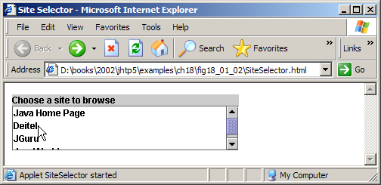



18.3 Reading a File on a Web Server

- Swing GUI component JEditorPane
  - Can display simple text and HTML formatted text
  - Can be used as a simple Web browser
    - Retrieves files from a Web server at a given URI

ReadServerFile.java

1 // Fig. 18.3: ReadServerFile.java
2 // Use a JEditorPane to display the contents of a file on a Web server.
3 import java.awt.*;
4 import java.awt.event.*;
5 import java.net.*;
6 import java.io.*;
7 import javax.swing.*;
8 import javax.swing.event.*;
9
10 public class ReadServerFile extends JFrame {
11 private JTextField enterField;
12 private JEditorPane contentsArea;
13
14 // set up GUI
15 public ReadServerFile()
16 {
17 super( "Simple Web Browser" );
18
19 Container container = getContentPane();
20
21 // create enterField and register its listener
22 enterField = new JTextField( "Enter file URL here" );
23 enterField.addActionListener(
24 new ActionListener() {
25
26 // get document specified by user
27 public void actionPerformed( ActionEvent event )
28 {
29 getThePage( event.getActionCommand() );
30 }
31
32 } // end inner class
33
34 ); // end call to addActionListener
35
36 container.add( enterField, BorderLayout.NORTH );
37
38 // create contentsArea and register HyperlinkEvent listener
39 contentsArea = new JEditorPane();
40 contentsArea.setEditable( false );
41 contentsArea.addHyperlinkListener(
42 new HyperlinkListener() {
43
44 // if user clicked hyperlink, go to specified page
45 public void hyperlinkUpdate( HyperlinkEvent event )
46 {
47 if ( event.getEventType() ==
48 HyperlinkEvent.EventType.ACTIVATED )
49 getThePage( event.getURL().toString() );
50 }
51
52 } // end inner class
53
54 ); // end call to addHyperlinkListener
55
56 container.add( new JScrollPane( contentsArea ),
57 BorderLayout.CENTER );
58 setSize( 400, 300 );
59 setVisible( true );
60
61 } // end constructor ReadServerFile
62
63 // load document
64 private void getThePage( String location )
65 {
66 // load document and display location
67 try {
68 contentsArea.setPage( location );
69 enterField.setText( location );
70 }
71 catch ( IOException ioException ) {
72 JOptionPane.showMessageDialog( this,
73 "Error retrieving specified URL", "Bad URL",
74 JOptionPane.ERROR_MESSAGE );
75 }
76
77 } // end method getThePage
78
79 public static void main( String args[] )
80 {
81 ReadServerFile application = new ReadServerFile();
82 application.setDefaultCloseOperation( JFrame.EXIT_ON_CLOSE );
83 }
84
85 } // end class ReadServerFile

ReadServerFile.java

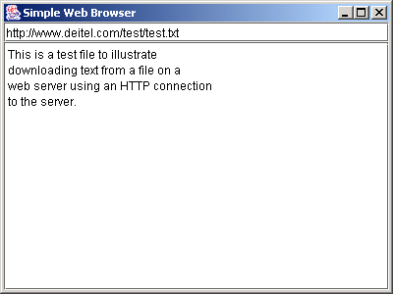
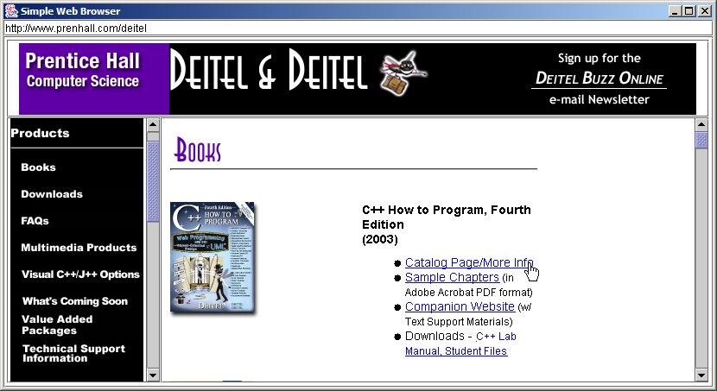

18.4 Establishing a Simple Server Using Stream Sockets

- Five steps to create a simple server in Java
  - ServerSocket object
    - Registers an available port and a maximum number of clients
  - Each client connection handled with Socket object
    - Server blocks until client connects
  - Sending and receiving data
    - OutputStream to send and InputStream to receive data
    - Methods getInputStream and getOutputstream
      - Use on Socket object
  - Process phase
    - Server and Client communicate via streams
  - Close streams and connections

18.5 Establishing a Simple Client Using Stream Sockets

- Four steps to create a simple client in Java
  - Create a Socket object for the client
  - Obtain Socket’s InputStream and Outputstream
  - Process information communicated
  - Close streams and Socket

18.6 Client/Server Interaction with Stream Socket Connections

- Client/server chat application
  - Uses stream sockets as described in last two sections

Server.java
1 // Fig. 18.4: Server.java
2 // Set up a Server that will receive a connection from a client, send
3 // a string to the client, and close the connection.
4 import java.io.*;
5 import java.net.*;
6 import java.awt.*;
7 import java.awt.event.*;
8 import javax.swing.*;
9
10 public class Server extends JFrame {
11 private JTextField enterField;
12 private JTextArea displayArea;
13 private ObjectOutputStream output;
14 private ObjectInputStream input;
15 private ServerSocket server;
16 private Socket connection;
17 private int counter = 1;
18
19 // set up GUI
20 public Server()
21 {
22 super( "Server" );
23
24 Container container = getContentPane();
25
26 // create enterField and register listener
27 enterField = new JTextField();
28 enterField.setEditable( false );
29 enterField.addActionListener(
30 new ActionListener() {
31
32 // send message to client
33 public void actionPerformed( ActionEvent event )
34 {
35 sendData( event.getActionCommand() );
36 enterField.setText( "" );
37 }
38 }
39 );
40
41 container.add( enterField, BorderLayout.NORTH );
42
43 // create displayArea
44 displayArea = new JTextArea();
45 container.add( new JScrollPane( displayArea ),
46 BorderLayout.CENTER );
47
48 setSize( 300, 150 );
49 setVisible( true );
50
51 } // end Server constructor
52
53 // set up and run server
54 public void runServer()
55 {
56 // set up server to receive connections; process connections
57 try {
58
59 // Step 1: Create a ServerSocket.
60 server = new ServerSocket( 12345, 100 );
61
62 while ( true ) {
63
64 try {
65 waitForConnection(); // Step 2: Wait for a connection.
66 getStreams(); // Step 3: Get input & output streams.
67 processConnection(); // Step 4: Process connection.
68 }
69
70 // process EOFException when client closes connection
71 catch ( EOFException eofException ) {
72 System.err.println( "Server terminated connection" );
73 }
74
75 finally {
76 closeConnection(); // Step 5: Close connection.
77 ++counter;
78 }
79
80 } // end while
81
82 } // end try
83
84 // process problems with I/O
85 catch ( IOException ioException ) {
86 ioException.printStackTrace();
87 }
88
89 } // end method runServer
90
91 // wait for connection to arrive, then display connection info
92 private void waitForConnection() throws IOException
93 {
94 displayMessage( "Waiting for connection\n" );
95 connection = server.accept(); // allow server to accept connection
96 displayMessage( "Connection " + counter + " received from: " +
97 connection.getInetAddress().getHostName() );
98 }
99
100 // get streams to send and receive data
101 private void getStreams() throws IOException
102 {
103 // set up output stream for objects
104 output = new ObjectOutputStream( connection.getOutputStream() );
105 output.flush(); // flush output buffer to send header information
106
107 // set up input stream for objects
108 input = new ObjectInputStream( connection.getInputStream() );
109
110 displayMessage( "\nGot I/O streams\n" );
111 }
112
113 // process connection with client
114 private void processConnection() throws IOException
115 {
116 // send connection successful message to client
117 String message = "Connection successful";
118 sendData( message );
119
120 // enable enterField so server user can send messages
121 setTextFieldEditable( true );
122
123 do { // process messages sent from client
124
125 // read message and display it
126 try {
127 message = ( String ) input.readObject();
128 displayMessage( "\n" + message );
129 }
130
131 // catch problems reading from client
132 catch ( ClassNotFoundException classNotFoundException ) {
133 displayMessage( "\nUnknown object type received" );
134 }
135
136 } while ( !message.equals( "CLIENT>>> TERMINATE" ) );
137
138 } // end method processConnection
139
140 // close streams and socket
141 private void closeConnection()
142 {
143 displayMessage( "\nTerminating connection\n" );
144 setTextFieldEditable( false ); // disable enterField
145
146 try {
147 output.close();
148 input.close();
149 connection.close();
150 }
151 catch( IOException ioException ) {
152 ioException.printStackTrace();
153 }
154 }
155
156 // send message to client
157 private void sendData( String message )
158 {
159 // send object to client
160 try {
161 output.writeObject( "SERVER>>> " + message );
162 output.flush();
163 displayMessage( "\nSERVER>>> " + message );
164 }
165
166 // process problems sending object
167 catch ( IOException ioException ) {
168 displayArea.append( "\nError writing object" );
169 }
170 }
171
172 // utility method called from other threads to manipulate
173 // displayArea in the event-dispatch thread
174 private void displayMessage( final String messageToDisplay )
175 {
176 // display message from event-dispatch thread of execution
177 SwingUtilities.invokeLater(
178 new Runnable() { // inner class to ensure GUI updates properly
179
180 public void run() // updates displayArea
181 {
182 displayArea.append( messageToDisplay );
183 displayArea.setCaretPosition(
184 displayArea.getText().length() );
185 }
186
187 } // end inner class
188
189 ); // end call to SwingUtilities.invokeLater
190 }
191
192 // utility method called from other threads to manipulate
193 // enterField in the event-dispatch thread
194 private void setTextFieldEditable( final boolean editable )
195 {
196 // display message from event-dispatch thread of execution
197 SwingUtilities.invokeLater(
198 new Runnable() { // inner class to ensure GUI updates properly
199
200 public void run() // sets enterField's editability
201 {
202 enterField.setEditable( editable );
203 }
204
205 } // end inner class
206
207 ); // end call to SwingUtilities.invokeLater
208 }
209
210 public static void main( String args[] )
211 {
212 Server application = new Server();
213 application.setDefaultCloseOperation( JFrame.EXIT_ON_CLOSE );
214 application.runServer();
215 }
216
217 } // end class Server

Client.java

1 // Fig. 18.5: Client.java
2 // Client that reads and displays information sent from a Server.
3 import java.io.*;
4 import java.net.*;
5 import java.awt.*;
6 import java.awt.event.*;
7 import javax.swing.*;
8
9 public class Client extends JFrame {
10 private JTextField enterField;
11 private JTextArea displayArea;
12 private ObjectOutputStream output;
13 private ObjectInputStream input;
14 private String message = "";
15 private String chatServer;
16 private Socket client;
17
18 // initialize chatServer and set up GUI
19 public Client( String host )
20 {
21 super( "Client" );
22
23 chatServer = host; // set server to which this client connects
24
25 Container container = getContentPane();
26
27 // create enterField and register listener
28 enterField = new JTextField();
29 enterField.setEditable( false );
30 enterField.addActionListener(
31 new ActionListener() {
32
33 // send message to server
34 public void actionPerformed( ActionEvent event )
35 {
36 sendData( event.getActionCommand() );
37 enterField.setText( "" );
38 }
39 }
40 );
41
42 container.add( enterField, BorderLayout.NORTH );
43
44 // create displayArea
45 displayArea = new JTextArea();
46 container.add( new JScrollPane( displayArea ),
47 BorderLayout.CENTER );
48
49 setSize( 300, 150 );
50 setVisible( true );
51
52 } // end Client constructor
53
54 // connect to server and process messages from server
55 private void runClient()
56 {
57 // connect to server, get streams, process connection
58 try {
59 connectToServer(); // Step 1: Create a Socket to make connection
60 getStreams(); // Step 2: Get the input and output streams
61 processConnection(); // Step 3: Process connection
62 }
63
64 // server closed connection
65 catch ( EOFException eofException ) {
66 System.err.println( "Client terminated connection" );
67 }
68
69 // process problems communicating with server
70 catch ( IOException ioException ) {
71 ioException.printStackTrace();
72 }
73
74 finally {
75 closeConnection(); // Step 4: Close connection
76 }
77
78 } // end method runClient
79
80 // connect to server
81 private void connectToServer() throws IOException
82 {
83 displayMessage( "Attempting connection\n" );
84
85 // create Socket to make connection to server
86 client = new Socket( InetAddress.getByName( chatServer ), 12345 );
87
88 // display connection information
89 displayMessage( "Connected to: " +
90 client.getInetAddress().getHostName() );
91 }
92
93 // get streams to send and receive data
94 private void getStreams() throws IOException
95 {
96 // set up output stream for objects
97 output = new ObjectOutputStream( client.getOutputStream() );
98 output.flush(); // flush output buffer to send header information
99
100 // set up input stream for objects
101 input = new ObjectInputStream( client.getInputStream() );
102
103 displayMessage( "\nGot I/O streams\n" );
104 }
105
106 // process connection with server
107 private void processConnection() throws IOException
108 {
109 // enable enterField so client user can send messages
110 setTextFieldEditable( true );
111
112 do { // process messages sent from server
113
114 // read message and display it
115 try {
116 message = ( String ) input.readObject();
117 displayMessage( "\n" + message );
118 }
119
120 // catch problems reading from server
121 catch ( ClassNotFoundException classNotFoundException ) {
122 displayMessage( "\nUnknown object type received" );
123 }
124
125 } while ( !message.equals( "SERVER>>> TERMINATE" ) );
126
127 } // end method processConnection128
129 // close streams and socket
130 private void closeConnection()
131 {
132 displayMessage( "\nClosing connection" );
133 setTextFieldEditable( false ); // disable enterField
134
135 try {
136 output.close();
137 input.close();
138 client.close();
139 }
140 catch( IOException ioException ) {
141 ioException.printStackTrace();
142 }
143 }
144
145 // send message to server
146 private void sendData( String message )
147 {
148 // send object to server
149 try {
150 output.writeObject( "CLIENT>>> " + message );
151 output.flush();
152 displayMessage( "\nCLIENT>>> " + message );
153 }
154
155 // process problems sending object
156 catch ( IOException ioException ) {
157 displayArea.append( "\nError writing object" );
158 }
159 }
160
161 // utility method called from other threads to manipulate
162 // displayArea in the event-dispatch thread
163 private void displayMessage( final String messageToDisplay )
164 {
165 // display message from GUI thread of execution
166 SwingUtilities.invokeLater(
167 new Runnable() { // inner class to ensure GUI updates properly
168
169 public void run() // updates displayArea
170 {
171 displayArea.append( messageToDisplay );
172 displayArea.setCaretPosition(
173 displayArea.getText().length() );
174 }
175
176 } // end inner class
177
178 ); // end call to SwingUtilities.invokeLater
179 }
180
181 // utility method called from other threads to manipulate
182 // enterField in the event-dispatch thread
183 private void setTextFieldEditable( final boolean editable )
184 {
185 // display message from GUI thread of execution
186 SwingUtilities.invokeLater(
187 new Runnable() { // inner class to ensure GUI updates properly
188
189 public void run() // sets enterField's editability
190 {
191 enterField.setEditable( editable );
192 }
193
194 } // end inner class
195
196 ); // end call to SwingUtilities.invokeLater
197 }
198
199 public static void main( String args[] )
200 {
201 Client application;
202
203 if ( args.length == 0 )
204 application = new Client( "127.0.0.1" );
205 else
206 application = new Client( args[ 0 ] );
207
208 application.setDefaultCloseOperation( JFrame.EXIT_ON_CLOSE );
209 application.runClient();
210 }
211
212 } // end class Client
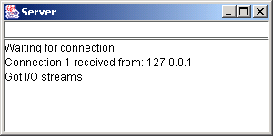
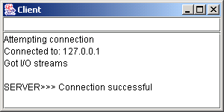
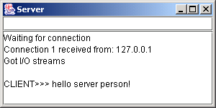
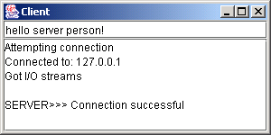

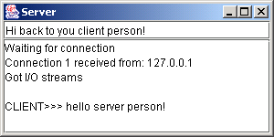
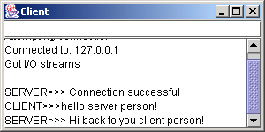

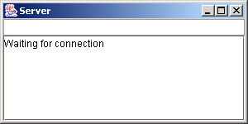
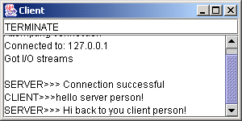

18.7 Connectionless Client/Server Interaction with Datagrams

- Connectionless transmission with datagrams
  - No connection maintained with other computer
  - Break message into equal sized pieces and send as packets
  - Message arrive in order, out of order or not at all
  - Receiver puts messages in order and reads them

Server.java

1 // Fig. 18.6: Server.java
2 // Server that receives and sends packets from/to a client.
3 import java.io.*;
4 import java.net.*;
5 import java.awt.*;
6 import java.awt.event.*;
7 import javax.swing.*;
8
9 public class Server extends JFrame {
10 private JTextArea displayArea;
11 private DatagramSocket socket;
12
13 // set up GUI and DatagramSocket
14 public Server()
15 {
16 super( "Server" );
17
18 displayArea = new JTextArea();
19 getContentPane().add( new JScrollPane( displayArea ),
20 BorderLayout.CENTER );
21 setSize( 400, 300 );
22 setVisible( true );
23
24 // create DatagramSocket for sending and receiving packets
25 try {
26 socket = new DatagramSocket( 5000 );
27 }
28
29 // process problems creating DatagramSocket
30 catch( SocketException socketException ) {
31 socketException.printStackTrace();
32 System.exit( 1 );
33 }
34
35 } // end Server constructor
36
37 // wait for packets to arrive, display data and echo packet to client
38 private void waitForPackets()
39 {
40 while ( true ) { // loop forever
41
42 // receive packet, display contents, return copy to client
43 try {
44
45 // set up packet
46 byte data[] = new byte[ 100 ];
47 DatagramPacket receivePacket =
48 new DatagramPacket( data, data.length );
49
50 socket.receive( receivePacket ); // wait for packet
51
52 // display information from received packet
53 displayMessage( "\nPacket received:" +
54 "\nFrom host: " + receivePacket.getAddress() +
55 "\nHost port: " + receivePacket.getPort() +
56 "\nLength: " + receivePacket.getLength() +
57 "\nContaining:\n\t" + new String( receivePacket.getData(),
58 0, receivePacket.getLength() ) );
59
60 sendPacketToClient( receivePacket ); // send packet to client
61 }
62
63 // process problems manipulating packet
64 catch( IOException ioException ) {
65 displayMessage( ioException.toString() + "\n" );
66 ioException.printStackTrace();
67 }
68
69 } // end while
70
71 } // end method waitForPackets
72
73 // echo packet to client
74 private void sendPacketToClient( DatagramPacket receivePacket )
75 throws IOException
76 {
77 displayMessage( "\n\nEcho data to client..." );
78
79 // create packet to send
80 DatagramPacket sendPacket = new DatagramPacket(
81 receivePacket.getData(), receivePacket.getLength(),
82 receivePacket.getAddress(), receivePacket.getPort() );
83
84 socket.send( sendPacket ); // send packet
85 displayMessage( "Packet sent\n" );
86 }
87
88 // utility method called from other threads to manipulate
89 // displayArea in the event-dispatch thread
90 private void displayMessage( final String messageToDisplay )
91 {
92 // display message from event-dispatch thread of execution
93 SwingUtilities.invokeLater(
94 new Runnable() { // inner class to ensure GUI updates properly
95
96 public void run() // updates displayArea
97 {
98 displayArea.append( messageToDisplay );
99 displayArea.setCaretPosition(
100 displayArea.getText().length() );
101 }
102
103 } // end inner class
104
105 ); // end call to SwingUtilities.invokeLater
106 }
107
108 public static void main( String args[] )
109 {
110 Server application = new Server();
111 application.setDefaultCloseOperation( JFrame.EXIT_ON_CLOSE );
112 application.waitForPackets();
113 }
114
115 } // end class Server

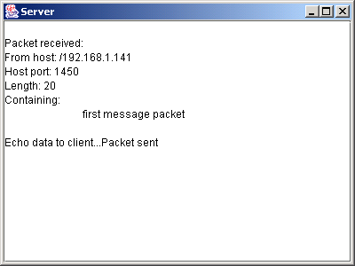

Client.java

1 // Fig. 18.7: Client.java
2 // Client that sends and receives packets to/from a server.
3 import java.io.*;
4 import java.net.*;
5 import java.awt.*;
6 import java.awt.event.*;
7 import javax.swing.*;
8
9 public class Client extends JFrame {
10 private JTextField enterField;
11 private JTextArea displayArea;
12 private DatagramSocket socket;
13
14 // set up GUI and DatagramSocket
15 public Client()
16 {
17 super( "Client" );
18
19 Container container = getContentPane();
20
21 enterField = new JTextField( "Type message here" );
22 enterField.addActionListener(
23 new ActionListener() {
24 public void actionPerformed( ActionEvent event )
25 {
26 // create and send packet
27 try {
28 displayArea.append( "\nSending packet containing: " +
29 event.getActionCommand() + "\n" );
30
31 // get message from textfield and convert to byte array
32 String message = event.getActionCommand();
33 byte data[] = message.getBytes();
34
35 // create sendPacket
36 DatagramPacket sendPacket = new DatagramPacket( data,
37 data.length, InetAddress.getLocalHost(), 5000 );
38
39 socket.send( sendPacket ); // send packet
40 displayArea.append( "Packet sent\n" );
41 displayArea.setCaretPosition(
42 displayArea.getText().length() );
43 }
44
45 // process problems creating or sending packet
46 catch ( IOException ioException ) {
47 displayMessage( ioException.toString() + "\n" );
48 ioException.printStackTrace();
49 }
50
51 } // end actionPerformed
52
53 } // end inner class
54
55 ); // end call to addActionListener
56
57 container.add( enterField, BorderLayout.NORTH );
58
59 displayArea = new JTextArea();
60 container.add( new JScrollPane( displayArea ),
61 BorderLayout.CENTER );
62
63 setSize( 400, 300 );
64 setVisible( true );
65
66 // create DatagramSocket for sending and receiving packets
67 try {
68 socket = new DatagramSocket();
69 }
70
71 // catch problems creating DatagramSocket
72 catch( SocketException socketException ) {
73 socketException.printStackTrace();
74 System.exit( 1 );
75 }
76
77 } // end Client constructor
78
79 // wait for packets to arrive from Server, display packet contents
80 private void waitForPackets()
81 {
82 while ( true ) { // loop forever
83
84 // receive packet and display contents
85 try {
86
87 // set up packet
88 byte data[] = new byte[ 100 ];
89 DatagramPacket receivePacket = new DatagramPacket(
90 data, data.length );
91
92 socket.receive( receivePacket ); // wait for packet
93
94 // display packet contents
95 displayMessage( "\nPacket received:" +
96 "\nFrom host: " + receivePacket.getAddress() +
97 "\nHost port: " + receivePacket.getPort() +
98 "\nLength: " + receivePacket.getLength() +
99 "\nContaining:\n\t" + new String( receivePacket.getData(),
100 0, receivePacket.getLength() ) );
101 }
102
103 // process problems receiving or displaying packet
104 catch( IOException exception ) {
105 displayMessage( exception.toString() + "\n" );
106 exception.printStackTrace();
107 }
108
109 } // end while
110
111 } // end method waitForPackets
112
113 // utility method called from other threads to manipulate
114 // displayArea in the event-dispatch thread
115 private void displayMessage( final String messageToDisplay )
116 {
117 // display message from event-dispatch thread of execution
118 SwingUtilities.invokeLater(
119 new Runnable() { // inner class to ensure GUI updates properly
120
121 public void run() // updates displayArea
122 {
123 displayArea.append( messageToDisplay );
124 displayArea.setCaretPosition(
125 displayArea.getText().length() );
126 }
127
128 } // end inner class
129
130 ); // end call to SwingUtilities.invokeLater
131 }
132
133 public static void main( String args[] )
134 {
135 Client application = new Client();
136 application.setDefaultCloseOperation( JFrame.EXIT_ON_CLOSE );
137 application.waitForPackets();
138 }
139
140 } // end class Client

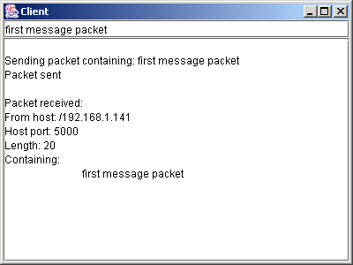

18.8 Client/Server Tic-Tac-Toe Using a Multithreaded Server

- Multiple threads
  - Server uses one thread per player
    - Allow each player to play game independently

TicTacToeServer.java

1 // Fig. 18.8: TicTacToeServer.java
2 // This class maintains a game of Tic-Tac-Toe for two client applets.
3 import java.awt.*;
4 import java.awt.event.*;
5 import java.net.*;
6 import java.io.*;
7 import javax.swing.*;
8
9 public class TicTacToeServer extends JFrame {
10 private char[] board;
11 private JTextArea outputArea;
12 private Player[] players;
13 private ServerSocket server;
14 private int currentPlayer;
15 private final int PLAYER_X = 0, PLAYER_O = 1;
16 private final char X_MARK = 'X', O_MARK = 'O';
17
18 // set up tic-tac-toe server and GUI that displays messages
19 public TicTacToeServer()
20 {
21 super( "Tic-Tac-Toe Server" );
22
23 board = new char[ 9 ];
24 players = new Player[ 2 ];
25 currentPlayer = PLAYER_X;
26
27 // set up ServerSocket
28 try {
29 server = new ServerSocket( 12345, 2 );
30 }
31
32 // process problems creating ServerSocket
33 catch( IOException ioException ) {
34 ioException.printStackTrace();
35 System.exit( 1 );
36 }
37
38 // set up JTextArea to display messages during execution
39 outputArea = new JTextArea();
40 getContentPane().add( outputArea, BorderLayout.CENTER );
41 outputArea.setText( "Server awaiting connections\n" );
42
43 setSize( 300, 300 );
44 setVisible( true );
45
46 } // end TicTacToeServer constructor
47
48 // wait for two connections so game can be played
49 public void execute()
50 {
51 // wait for each client to connect
52 for ( int i = 0; i < players.length; i++ ) {
53
54 // wait for connection, create Player, start thread
55 try {
56 players[ i ] = new Player( server.accept(), i );
57 players[ i ].start();
58 }
59
60 // process problems receiving connection from client
61 catch( IOException ioException ) {
62 ioException.printStackTrace();
63 System.exit( 1 );
64 }
65 }
66
67 // Player X is suspended until Player O connects.
68 // Resume player X now.
69 synchronized ( players[ PLAYER_X ] ) {
70 players[ PLAYER_X ].setSuspended( false );
71 players[ PLAYER_X ].notify();
72 }
73
74 } // end method execute
75
76 // utility method called from other threads to manipulate
77 // outputArea in the event-dispatch thread
78 private void displayMessage( final String messageToDisplay )
79 {
80 // display message from event-dispatch thread of execution
81 SwingUtilities.invokeLater(
82 new Runnable() { // inner class to ensure GUI updates properly
83
84 public void run() // updates outputArea
85 {
86 outputArea.append( messageToDisplay );
87 outputArea.setCaretPosition(
88 outputArea.getText().length() );
89 }
90
91 } // end inner class
92
93 ); // end call to SwingUtilities.invokeLater
94 }
95
96 // Determine if a move is valid. This method is synchronized because
97 // only one move can be made at a time.
98 public synchronized boolean validateAndMove( int location, int player )
99 {
100 boolean moveDone = false;
101
102 // while not current player, must wait for turn
103 while ( player != currentPlayer ) {
104
105 // wait for turn
106 try {
107 wait();
108 }
109
110 // catch wait interruptions
111 catch( InterruptedException interruptedException ) {
112 interruptedException.printStackTrace();
113 }
114 }
115
116 // if location not occupied, make move
117 if ( !isOccupied( location ) ) {
118
119 // set move in board array
120 board[ location ] = currentPlayer == PLAYER_X ? X_MARK : O_MARK;
121
122 // change current player
123 currentPlayer = ( currentPlayer + 1 ) % 2;
124
125 // let new current player know that move occurred
126 players[ currentPlayer ].otherPlayerMoved( location );
127
128 notify(); // tell waiting player to continue
129
130 // tell player that made move that the move was valid
131 return true;
132 }
133
134 // tell player that made move that the move was not valid
135 else
136 return false;
137
138 } // end method validateAndMove
139
140 // determine whether location is occupied
141 public boolean isOccupied( int location )
142 {
143 if ( board[ location ] == X_MARK || board [ location ] == O_MARK )
144 return true;
145 else
146 return false;
147 }
148
149 // place code in this method to determine whether game over
150 public boolean isGameOver()
151 {
152 return false; // this is left as an exercise
153 }
154
155 public static void main( String args[] )
156 {
157 TicTacToeServer application = new TicTacToeServer();
158 application.setDefaultCloseOperation( JFrame.EXIT_ON_CLOSE );
159 application.execute();
160 }
161
162 // private inner class Player manages each Player as a thread
163 private class Player extends Thread {
164 private Socket connection;
165 private DataInputStream input;
166 private DataOutputStream output;
167 private int playerNumber;
168 private char mark;
169 protected boolean suspended = true;
170
171 // set up Player thread
172 public Player( Socket socket, int number )
173 {
174 playerNumber = number;
175
176 // specify player's mark
177 mark = ( playerNumber == PLAYER_X ? X_MARK : O_MARK );
178
179 connection = socket;
180
181 // obtain streams from Socket
182 try {
183 input = new DataInputStream( connection.getInputStream() );
184 output = new DataOutputStream( connection.getOutputStream() );
185 }
186
187 // process problems getting streams
188 catch( IOException ioException ) {
189 ioException.printStackTrace();
190 System.exit( 1 );
191 }
192
193 } // end Player constructor
194
195 // send message that other player moved
196 public void otherPlayerMoved( int location )
197 {
198 // send message indicating move
199 try {
200 output.writeUTF( "Opponent moved" );
201 output.writeInt( location );
202 }
203
204 // process problems sending message
205 catch ( IOException ioException ) {
206 ioException.printStackTrace();
207 }
208 }
209
210 // control thread's execution
211 public void run()
212 {
213 // send client message indicating its mark (X or O),
214 // process messages from client
215 try {
216 displayMessage( "Player " + ( playerNumber ==
217 PLAYER_X ? X_MARK : O_MARK ) + " connected\n" );
218
219 output.writeChar( mark ); // send player's mark
220
221 // send message indicating connection
222 output.writeUTF( "Player " + ( playerNumber == PLAYER_X ?
223 "X connected\n" : "O connected, please wait\n" ) );
224
225 // if player X, wait for another player to arrive
226 if ( mark == X_MARK ) {
227 output.writeUTF( "Waiting for another player" );
228
229 // wait for player O
230 try {
231 synchronized( this ) {
232 while ( suspended )
233 wait();
234 }
235 }
236
237 // process interruptions while waiting
238 catch ( InterruptedException exception ) {
239 exception.printStackTrace();
240 }
241
242 // send message that other player connected and
243 // player X can make a move
244 output.writeUTF( "Other player connected. Your move." );
245 }
246
247 // while game not over
248 while ( ! isGameOver() ) {
249
250 // get move location from client
251 int location = input.readInt();
252
253 // check for valid move
254 if ( validateAndMove( location, playerNumber ) ) {
255 displayMessage( "\nlocation: " + location );
256 output.writeUTF( "Valid move." );
257 }
258 else
259 output.writeUTF( "Invalid move, try again" );
260 }
261
262 connection.close(); // close connection to client
263
264 } // end try
265
266 // process problems communicating with client
267 catch( IOException ioException ) {
268 ioException.printStackTrace();
269 System.exit( 1 );
270 }
271
272 } // end method run
273
274 // set whether or not thread is suspended
275 public void setSuspended( boolean status )
276 {
277 suspended = status;
278 }
279
280 } // end class Player
281
282 } // end class TicTacToeServer

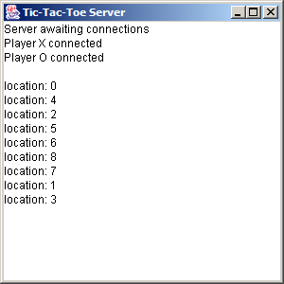

TicTacToeClient.java

1 // Fig. 18.9: TicTacToeClient.java
2 // Client that let a user play Tic-Tac-Toe with another across a network.
3 import java.awt.*;
4 import java.awt.event.*;
5 import java.net.*;
6 import java.io.*;
7 import javax.swing.*;
8
9 public class TicTacToeClient extends JApplet implements Runnable {
10 private JTextField idField;
11 private JTextArea displayArea;
12 private JPanel boardPanel, panel2;
13 private Square board[][], currentSquare;
14 private Socket connection;
15 private DataInputStream input;
16 private DataOutputStream output;
17 private char myMark;
18 private boolean myTurn;
19 private final char X_MARK = 'X', O_MARK = 'O';
20
21 // Set up user-interface and board
22 public void init()
23 {
24 Container container = getContentPane();
25
26 // set up JTextArea to display messages to user
27 displayArea = new JTextArea( 4, 30 );
28 displayArea.setEditable( false );
29 container.add( new JScrollPane( displayArea ), BorderLayout.SOUTH );
30
31 // set up panel for squares in board
32 boardPanel = new JPanel();
33 boardPanel.setLayout( new GridLayout( 3, 3, 0, 0 ) );
34
35 // create board
36 board = new Square[ 3 ][ 3 ];
37
38 // When creating a Square, the location argument to the constructor
39 // is a value from 0 to 8 indicating the position of the Square on
40 // the board. Values 0, 1, and 2 are the first row, values 3, 4,
41 // and 5 are the second row. Values 6, 7, and 8 are the third row.
42 for ( int row = 0; row < board.length; row++ ) {
43
44 for ( int column = 0; column < board[ row ].length; column++ ) {
45
46 // create Square
47 board[ row ][ column ] = new Square( ' ', row * 3 + column );
48 boardPanel.add( board[ row ][ column ] );
49 }
50 }
51
52 // textfield to display player's mark
53 idField = new JTextField();
54 idField.setEditable( false );
55 container.add( idField, BorderLayout.NORTH );
56
57 // set up panel to contain boardPanel (for layout purposes)
58 panel2 = new JPanel();
59 panel2.add( boardPanel, BorderLayout.CENTER );
60 container.add( panel2, BorderLayout.CENTER );
61
62 } // end method init
63
64 // Make connection to server and get associated streams.
65 // Start separate thread to allow this applet to
66 // continually update its output in textarea display.
67 public void start()
68 {
69 // connect to server, get streams and start outputThread
70 try {
71
72 // make connection
73 connection = new Socket( getCodeBase().getHost(), 12345 );
74
75 // get streams
76 input = new DataInputStream( connection.getInputStream() );
77 output = new DataOutputStream( connection.getOutputStream() );
78 }
79
80 // catch problems setting up connection and streams
81 catch ( IOException ioException ) {
82 ioException.printStackTrace();
83 }
84
85 // create and start output thread
86 Thread outputThread = new Thread( this );
87 outputThread.start();
88
89 } // end method start
90
91 // control thread that allows continuous update of displayArea
92 public void run()
93 {
94 // get player's mark (X or O)
95 try {
96 myMark = input.readChar();
97
98 // display player ID in event-dispatch thread
99 SwingUtilities.invokeLater(
100 new Runnable() {
101 public void run()
102 {
103 idField.setText( "You are player \"" + myMark + "\"" );
104 }
105 }
106 );
107
108 myTurn = ( myMark == X_MARK ? true : false );
109
110 // receive messages sent to client and output them
111 while ( true ) {
112 processMessage( input.readUTF() );
113 }
114
115 } // end try
116
117 // process problems communicating with server
118 catch ( IOException ioException ) {
119 ioException.printStackTrace();
120 }
121
122 } // end method run
123
124 // process messages received by client
125 private void processMessage( String message )
126 {
127 // valid move occurred
128 if ( message.equals( "Valid move." ) ) {
129 displayMessage( "Valid move, please wait.\n" );
130 setMark( currentSquare, myMark );
131 }
132
133 // invalid move occurred
134 else if ( message.equals( "Invalid move, try again" ) ) {
135 displayMessage( message + "\n" );
136 myTurn = true;
137 }
138
139 // opponent moved
140 else if ( message.equals( "Opponent moved" ) ) {
141
142 // get move location and update board
143 try {
144 int location = input.readInt();
145 int row = location / 3;
146 int column = location % 3;
147
148 setMark( board[ row ][ column ],
149 ( myMark == X_MARK ? O_MARK : X_MARK ) );
150 displayMessage( "Opponent moved. Your turn.\n" );
151 myTurn = true;
152
153 } // end try
154
155 // process problems communicating with server
156 catch ( IOException ioException ) {
157 ioException.printStackTrace();
158 }
159
160 } // end else if
161
162 // simply display message
163 else
164 displayMessage( message + "\n" );
165
166 } // end method processMessage
167
168 // utility method called from other threads to manipulate
169 // outputArea in the event-dispatch thread
170 private void displayMessage( final String messageToDisplay )
171 {
172 // display message from event-dispatch thread of execution
173 SwingUtilities.invokeLater(
174 new Runnable() { // inner class to ensure GUI updates properly
175
176 public void run() // updates displayArea
177 {
178 displayArea.append( messageToDisplay );
179 displayArea.setCaretPosition(
180 displayArea.getText().length() );
181 }
182
183 } // end inner class
184
185 ); // end call to SwingUtilities.invokeLater
186 }
187
188 // utility method to set mark on board in event-dispatch thread
189 private void setMark( final Square squareToMark, final char mark )
190 {
191 SwingUtilities.invokeLater(
192 new Runnable() {
193 public void run()
194 {
195 squareToMark.setMark( mark );
196 }
197 }
198 );
199 }
200
201 // send message to server indicating clicked square
202 public void sendClickedSquare( int location )
203 {
204 if ( myTurn ) {
205
206 // send location to server
207 try {
208 output.writeInt( location );
209 myTurn = false;
210 }
211
212 // process problems communicating with server
213 catch ( IOException ioException ) {
214 ioException.printStackTrace();
215 }
216 }
217 }
218
219 // set current Square
220 public void setCurrentSquare( Square square )
221 {
222 currentSquare = square;
223 }
224
225 // private inner class for the squares on the board
226 private class Square extends JPanel {
227 private char mark;
228 private int location;
229
230 public Square( char squareMark, int squareLocation )
231 {
232 mark = squareMark;
233 location = squareLocation;
234
235 addMouseListener(
236 new MouseAdapter() {
237 public void mouseReleased( MouseEvent e )
238 {
239 setCurrentSquare( Square.this );
240 sendClickedSquare( getSquareLocation() );
241 }
242 }
243 );
244
245 } // end Square constructor
246
247 // return preferred size of Square
248 public Dimension getPreferredSize()
249 {
250 return new Dimension( 30, 30 );
251 }
252
253 // return minimum size of Square
254 public Dimension getMinimumSize()
255 {
256 return getPreferredSize();
257 }
258
259 // set mark for Square
260 public void setMark( char newMark )
261 {
262 mark = newMark;
263 repaint();
264 }
265
266 // return Square location
267 public int getSquareLocation()
268 {
269 return location;
270 }
271
272 // draw Square
273 public void paintComponent( Graphics g )
274 {
275 super.paintComponent( g );
276
277 g.drawRect( 0, 0, 29, 29 );
278 g.drawString( String.valueOf( mark ), 11, 20 );
279 }
280
281 } // end inner-class Square
282
283 } // end class TicTacToeClient

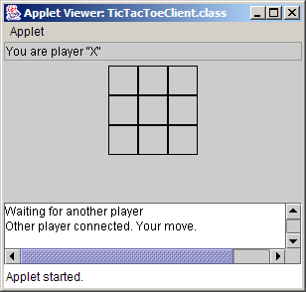
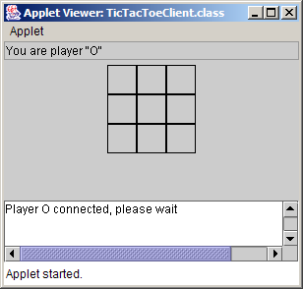

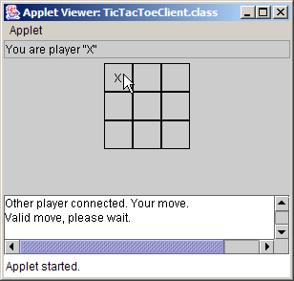
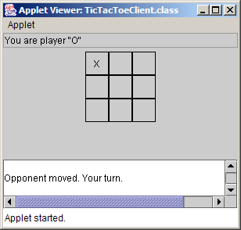

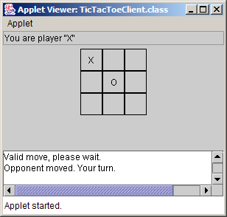
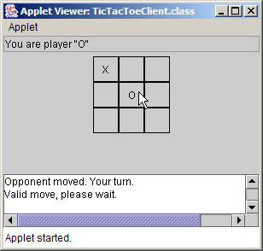

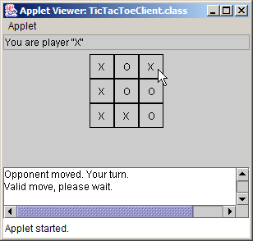
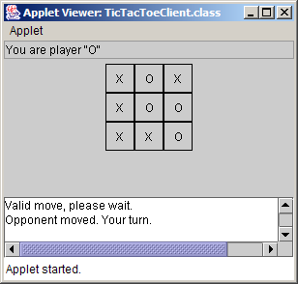

18.9 Security and the Network

- By default, applets cannot perform file processing
- Applets often limited in machine access
- Java Security API
  - Applets given more privileges if from trusted source

18.10 DeitelMessenger Chat Server and Client

- Chat rooms
  - Each user can post a message and read all other messages
  - Multicast
    - Send packets to groups of clients

18.10.1 DeitelMessengerServer and Supporting Classes

- DeitelMessengerServer
  - Online chat system
  - Classes:
    - DeitelMessengerServer
      - Clients connect to this server
    - Interface SocketMessengerConstants
      - Defines constants for port numbers
    - Interface MessageListener
      - Defines method for receiving new chat messages
    - Class ReceivingThread
      - Separate thread listens for messages from clients
    - Class MulticastSendingThread
      - Separate thread delivers outgoing messages to clients

DeitelMessengerServer.java

1 // Fig. 18.11: DeitelMessengerServer.java
2 // DeitelMessengerServer is a multi-threaded, socket- and
3 // packet-based chat server.
4 package com.deitel.messenger.sockets.server;
5
6 import java.util.*;
7 import java.net.*;
8 import java.io.*;
9
10 import com.deitel.messenger.*;
11 import com.deitel.messenger.sockets.*;
12
13 public class DeitelMessengerServer implements MessageListener {
14
15 // start chat server
16 public void startServer()
17 {
18 // create server and manage new clients
19 try {
20
21 // create ServerSocket for incoming connections
22 ServerSocket serverSocket = new ServerSocket(
23 SocketMessengerConstants.SERVER_PORT, 100 );
24
25 System.out.println( "Server listening on port " +
26 SocketMessengerConstants.SERVER_PORT + " ..." );
27
28 // listen for clients constantly
29 while ( true ) {
30
31 // accept new client connection
32 Socket clientSocket = serverSocket.accept();
33
34 // create new ReceivingThread for receiving
35 // messages from client
36 new ReceivingThread( this, clientSocket ).start();
37
38 // print connection information
39 System.out.println( "Connection received from: " +
40 clientSocket.getInetAddress() );
41
42 } // end while
43
44 } // end try
45
46 // handle exception creating server and connecting clients
47 catch ( IOException ioException ) {
48 ioException.printStackTrace();
49 }
50
51 } // end method startServer
52
53 // when new message is received, broadcast message to clients
54 public void messageReceived( String from, String message )
55 {
56 // create String containing entire message
57 String completeMessage = from +
58 SocketMessengerConstants.MESSAGE_SEPARATOR + message;
59
60 // create and start MulticastSendingThread to broadcast
61 // new messages to all clients
62 new MulticastSendingThread( completeMessage.getBytes() ).start();
63 }
64
65 public static void main ( String args[] )
66 {
67 new DeitelMessengerServer().startServer();
68 }
69
70 } // end class DeitelMessengerServer

Server listening on port 5000 ...
Connection received from: SEANSANTRY/XXX.XXX.XXX.XXX
Connection received from: PJD/XXX.XXX.XXX.XXX

SocketMessengerConstants.java

1 // Fig. 18.12: SocketMessengerConstants.java
2 // SocketMessengerConstants declares constants for the port numbers
3 // and multicast address in DeitelMessenger
4 package com.deitel.messenger.sockets;
5
6 public interface SocketMessengerConstants {
7
8 // address for multicast datagrams
9 public static final String MULTICAST_ADDRESS = "239.0.0.1";
10
11 // port for listening for multicast datagrams
12 public static final int MULTICAST_LISTENING_PORT = 5555;
13
14 // port for sending multicast datagrams
15 public static final int MULTICAST_SENDING_PORT = 5554;
16
17 // port for Socket connections to DeitelMessengerServer
18 public static final int SERVER_PORT = 5000;
19
20 // String that indicates disconnect
21 public static final String DISCONNECT_STRING = "DISCONNECT";
22
23 // String that separates the user name from the message body
24 public static final String MESSAGE_SEPARATOR = ">>>";
25
26 // message size (in bytes)
27 public static final int MESSAGE_SIZE = 512;
28 }

MessageListener.java

1 // Fig. 18.13: MessageListener.java
2 // MessageListener is an interface for classes that wish to
3 // receive new chat messages.
4 package com.deitel.messenger;
5
6 public interface MessageListener {
7
8 // receive new chat message
9 public void messageReceived( String from, String message );
10 }

ReceivingThread.java

1 // Fig. 18.14: ReceivingThread.java
2 // ReceivingThread is a Thread that listens for messages from a
3 // particular client and delivers messages to a MessageListener.
4 package com.deitel.messenger.sockets.server;
5
6 import java.io.*;
7 import java.net.*;
8 import java.util.StringTokenizer;
9
10 import com.deitel.messenger.*;
11 import com.deitel.messenger.sockets.*;
12
13 public class ReceivingThread extends Thread {
14
15 private BufferedReader input;
16 private MessageListener messageListener;
17 private boolean keepListening = true;
18
19 // ReceivingThread constructor
20 public ReceivingThread( MessageListener listener, Socket clientSocket )
21 {
22 // invoke superclass constructor to name Thread
23 super( "ReceivingThread: " + clientSocket );
24
25 // set listener to which new messages should be sent
26 messageListener = listener;
27
28 // set timeout for reading from clientSocket and create
29 // BufferedReader for reading incoming messages
30 try {
31 clientSocket.setSoTimeout( 5000 );
32
33 input = new BufferedReader( new InputStreamReader(
34 clientSocket.getInputStream() ) );
35 }
36
37 // handle exception creating BufferedReader
38 catch ( IOException ioException ) {
39 ioException.printStackTrace();
40 }
41
42 } // end ReceivingThread constructor
43
44 // listen for new messages and deliver them to MessageListener
45 public void run()
46 {
47 String message;
48
49 // listen for messages until stopped
50 while ( keepListening ) {
51
52 // read message from BufferedReader
53 try {
54 message = input.readLine();
55 }
56
57 // handle exception if read times out
58 catch ( InterruptedIOException interruptedIOException ) {
59
60 // continue to next iteration to keep listening
61 continue;
62 }
63
64 // handle exception reading message
65 catch ( IOException ioException ) {
66 ioException.printStackTrace();
67 break;
68 }
69
70 // ensure non-null message
71 if ( message != null ) {
72
73 // tokenize message to retrieve user name and message body
74 StringTokenizer tokenizer = new StringTokenizer(
75 message, SocketMessengerConstants.MESSAGE_SEPARATOR );
76
77 // ignore messages that do not contain a user
78 // name and message body
79 if ( tokenizer.countTokens() == 2 )
80
81 // send message to MessageListener
82 messageListener.messageReceived(
83 tokenizer.nextToken(), // user name
84 tokenizer.nextToken() ); // message body
85
86 else
87
88 // if disconnect message received, stop listening
89 if ( message.equalsIgnoreCase(
90 SocketMessengerConstants.MESSAGE_SEPARATOR +
91 SocketMessengerConstants.DISCONNECT_STRING ) )
92 stopListening();
93
94 } // end if
95
96 } // end while
97
98 // close BufferedReader (also closes Socket)
99 try {
100 input.close();
101 }
102
103 // handle exception closing BufferedReader
104 catch ( IOException ioException ) {
105 ioException.printStackTrace();
106 }
107
108 } // end method run
109
110 // stop listening for incoming messages
111 public void stopListening()
112 {
113 keepListening = false;
114 }
115
116 } // end class ReceivingThread

MulticastSendingThread.java

1 // Fig. 18.15: MulticastSendingThread.java
2 // MulticastSendingThread is a Thread that broadcasts a chat
3 // message using a multicast datagram.
4 package com.deitel.messenger.sockets.server;
5
6 import java.io.*;
7 import java.net.*;
8
9 import com.deitel.messenger.sockets.*;
10
11 public class MulticastSendingThread extends Thread {
12
13 // message data
14 private byte[] messageBytes;
15
16 // MulticastSendingThread constructor
17 public MulticastSendingThread( byte[] bytes )
18 {
19 // invoke superclass constructor to name Thread
20 super( "MulticastSendingThread" );
21
22 messageBytes = bytes;
23 }
24
25 // deliver message to MULTICAST_ADDRESS over DatagramSocket
26 public void run()
27 {
28 // deliver message
29 try {
30
31 // create DatagramSocket for sending message
32 DatagramSocket socket = new DatagramSocket(
33 SocketMessengerConstants.MULTICAST_SENDING_PORT );
34
35 // use InetAddress reserved for multicast group
36 InetAddress group = InetAddress.getByName(
37 SocketMessengerConstants.MULTICAST_ADDRESS );
38
39 // create DatagramPacket containing message
40 DatagramPacket packet = new DatagramPacket( messageBytes,
41 messageBytes.length, group,
42 SocketMessengerConstants.MULTICAST_LISTENING_PORT );
43
44 // send packet to multicast group and close socket
45 socket.send( packet );
46 socket.close();
47 }
48
49 // handle exception delivering message
50 catch ( IOException ioException ) {
51 ioException.printStackTrace();
52 }
53
54 } // end method run
55
56 } // end class MulticastSendingThread

18.10.2 DeitelMessenger Client and Supporting Classes

- DeitelMessengerServer client
  - Consists of five components
    - Interface MessageManager
    - Class that implements interface MessageManager
      - Manages communication with server
    - Thread subclass
      - Listens for messages at server’s multicast address
    - Another Thread subclass
      - Sends messages from client to server
    - JFrame subclass
      - Provides client GUI

MessageManager.java

1 // Fig. 18.16: MessageManager.java
2 // MessageManager is an interface for objects capable of managing
3 // communications with a message server.
4 package com.deitel.messenger;
5
6 public interface MessageManager {
7
8 // connect to message server and route incoming messages
9 // to given MessageListener
10 public void connect( MessageListener listener );
11
12 // disconnect from message server and stop routing
13 // incoming messages to given MessageListener
14 public void disconnect( MessageListener listener );
15
16 // send message to message server
17 public void sendMessage( String from, String message );
18 }

SocketMessageManager.java

1 // Fig. 18.17: SocketMessageManager.java
2 // SocketMessageManager communicates with a DeitelMessengerServer using
3 // Sockets and MulticastSockets.
4 package com.deitel.messenger.sockets.client;
5
6 import java.util.*;
7 import java.net.*;
8 import java.io.*;
9
10 import com.deitel.messenger.*;
11 import com.deitel.messenger.sockets.*;
12
13 public class SocketMessageManager implements MessageManager {
14
15 // Socket for outgoing messages
16 private Socket clientSocket;
17
18 // DeitelMessengerServer address
19 private String serverAddress;
20
21 // Thread for receiving multicast messages
22 private PacketReceivingThread receivingThread;
23
24 // flag indicating connection status
25 private boolean connected = false;
26
27 // SocketMessageManager constructor
28 public SocketMessageManager( String address )
29 {
30 serverAddress = address;
31 }
32
33 // connect to server and send messages to given MessageListener
34 public void connect( MessageListener listener )
35 {
36 // if already connected, return immediately
37 if ( connected )
38 return;
39
40 // open Socket connection to DeitelMessengerServer
41 try {
42 clientSocket = new Socket(
43 InetAddress.getByName( serverAddress ),
44 SocketMessengerConstants.SERVER_PORT );
45
46 // create Thread for receiving incoming messages
47 receivingThread = new PacketReceivingThread( listener );
48 receivingThread.start();
49
50 // update connected flag
51 connected = true;
52 }
53
54 // handle exception connecting to server
55 catch ( IOException ioException ) {
56 ioException.printStackTrace();
57 }
58
59 } // end method connect
60
61 // disconnect from server and unregister given MessageListener
62 public void disconnect( MessageListener listener )
63 {
64 // if not connected, return immediately
65 if ( !connected )
66 return;
67
68 // stop listening thread and disconnect from server
69 try {
70
71 // notify server that client is disconnecting
72 Thread disconnectThread = new SendingThread( clientSocket, "",
73 SocketMessengerConstants.DISCONNECT_STRING );
74 disconnectThread.start();
75
76 // wait 10 seconds for disconnect message to be sent
77 disconnectThread.join( 10000 );
78
79 // stop receivingThread and remove given MessageListener
80 receivingThread.stopListening();
81
82 // close outgoing Socket
83 clientSocket.close();
84
85 } // end try
86
87 // handle exception disconnecting from server
88 catch ( IOException ioException ) {
89 ioException.printStackTrace();
90 }
91
92 // handle exception joining disconnectThread
93 catch ( InterruptedException interruptedException ) {
94 interruptedException.printStackTrace();
95 }
96
97 // update connected flag
98 connected = false;
99
100 } // end method disconnect
101
102 // send message to server
103 public void sendMessage( String from, String message )
104 {
105 // if not connected, return immediately
106 if ( !connected )
107 return;
108
109 // create and start new SendingThread to deliver message
110 new SendingThread( clientSocket, from, message).start();
111 }
112
113 } // end method SocketMessageManager
SendingThread.java

1 // Fig. 18.18: SendingThread.java
2 // SendingThread sends a message to the chat server in a separate Thread.
3 package com.deitel.messenger.sockets.client;
4
5 import java.io.*;
6 import java.net.*;
7
8 import com.deitel.messenger.sockets.*;
9
10 public class SendingThread extends Thread {
11
12 // Socket over which to send message
13 private Socket clientSocket;
14 private String messageToSend;
15
16 // SendingThread constructor
17 public SendingThread( Socket socket, String userName, String message )
18 {
19 // invoke superclass constructor to name Thread
20 super( "SendingThread: " + socket );
21
22 clientSocket = socket;
23
24 // build the message to be sent
25 messageToSend = userName +
26 SocketMessengerConstants.MESSAGE_SEPARATOR + message;
27 }
28
29 // send message and exit Thread
30 public void run()
31 {
32 // send message and flush PrintWriter
33 try {
34 PrintWriter writer =
35 new PrintWriter( clientSocket.getOutputStream() );
36 writer.println( messageToSend );
37 writer.flush();
38 }
39
40 // handle exception sending message
41 catch ( IOException ioException ) {
42 ioException.printStackTrace();
43 }
44 }
45
46 } // end class SendingThread

PacketReceivingThread.java

1 // Fig. 18.19: PacketReceivingThread.java
2 // PacketReceivingThread listens for DatagramPackets containing
3 // messages from a DeitelMessengerServer.
4 package com.deitel.messenger.sockets.client;
5
6 import java.io.*;
7 import java.net.*;
8 import java.util.*;
9
10 import com.deitel.messenger.*;
11 import com.deitel.messenger.sockets.*;
12
13 public class PacketReceivingThread extends Thread {
14
15 // MessageListener to whom messages should be delivered
16 private MessageListener messageListener;
17
18 // MulticastSocket for receiving broadcast messages
19 private MulticastSocket multicastSocket;
20
21 // InetAddress of group for messages
22 private InetAddress multicastGroup;
23
24 // flag for terminating PacketReceivingThread
25 private boolean keepListening = true;
26
27 // PacketReceivingThread constructor
28 public PacketReceivingThread( MessageListener listener )
29 {
30 // invoke superclass constructor to name Thread
31 super( "PacketReceivingThread" );
32
33 // set MessageListener
34 messageListener = listener;
35
36 // connect MulticastSocket to multicast address and port
37 try {
38 multicastSocket = new MulticastSocket(
39 SocketMessengerConstants.MULTICAST_LISTENING_PORT );
40
41 multicastGroup = InetAddress.getByName(
42 SocketMessengerConstants.MULTICAST_ADDRESS );
43
44 // join multicast group to receive messages
45 multicastSocket.joinGroup( multicastGroup );
46
47 // set 5 second timeout when waiting for new packets
48 multicastSocket.setSoTimeout( 5000 );
49 }
50
51 // handle exception connecting to multicast address
52 catch ( IOException ioException ) {
53 ioException.printStackTrace();
54 }
55
56 } // end PacketReceivingThread constructor
57
58 // listen for messages from multicast group
59 public void run()
60 {
61 // listen for messages until stopped
62 while ( keepListening ) {
63
64 // create buffer for incoming message
65 byte[] buffer =
66 new byte[ SocketMessengerConstants.MESSAGE_SIZE ];
67
68 // create DatagramPacket for incoming message
69 DatagramPacket packet = new DatagramPacket( buffer,
70 SocketMessengerConstants.MESSAGE_SIZE );
71
72 // receive new DatagramPacket (blocking call)
73 try {
74 multicastSocket.receive( packet );
75 }
76
77 // handle exception when receive times out
78 catch ( InterruptedIOException interruptedIOException ) {
79
80 // continue to next iteration to keep listening
81 continue;
82 }
83
84 // handle exception reading packet from multicast group
85 catch ( IOException ioException ) {
86 ioException.printStackTrace();
87 break;
88 }
89
90 // put message data in a String
91 String message = new String( packet.getData() );
92
93 // trim extra white space from end of message
94 message = message.trim();
95
96 // tokenize message to retrieve user name and message body
97 StringTokenizer tokenizer = new StringTokenizer(
98 message, SocketMessengerConstants.MESSAGE_SEPARATOR );
99
100 // ignore messages that do not contain a user
101 // name and message body
102 if ( tokenizer.countTokens() == 2 )
103
104 // send message to MessageListener
105 messageListener.messageReceived(
106 tokenizer.nextToken(), // user name
107 tokenizer.nextToken() ); // message body
108
109 } // end while
110
111 // leave multicast group and close MulticastSocket
112 try {
113 multicastSocket.leaveGroup( multicastGroup );
114 multicastSocket.close();
115 }
116
117 // handle exception reading packet from multicast group
118 catch ( IOException ioException ) {
119 ioException.printStackTrace();
120 }
121
122 } // end method run
123
124 // stop listening for new messages
125 public void stopListening()
126 {
127 keepListening = false;
128 }
129
130 } // end class PacketReceivingThread

ClientGUI.java
1 // Fig. 18.20: ClientGUI.java
2 // ClientGUI provides a user interface for sending and receiving
3 // messages to and from the DeitelMessengerServer.
4 package com.deitel.messenger;
5
6 import java.io.*;
7 import java.net.*;
8 import java.awt.*;
9 import java.awt.event.*;
10 import javax.swing.*;
11 import javax.swing.border.*;
12
13 public class ClientGUI extends JFrame {
14
15 // JMenu for connecting/disconnecting server
16 private JMenu serverMenu;
17
18 // JTextAreas for displaying and inputting messages
19 private JTextArea messageArea;
20 private JTextArea inputArea;
21
22 // JButtons and JMenuItems for connecting and disconnecting
23 private JButton connectButton;
24 private JMenuItem connectMenuItem;
25 private JButton disconnectButton;
26 private JMenuItem disconnectMenuItem;
27
28 // JButton for sending messages
29 private JButton sendButton;
30
31 // JLabel for displaying connection status
32 private JLabel statusBar;
33
34 // userName to add to outgoing messages
35 private String userName;
36
37 // MessageManager for communicating with server
38 private MessageManager messageManager;
39
40 // MessageListener for receiving incoming messages
41 private MessageListener messageListener;
42
43 // ClientGUI constructor
44 public ClientGUI( MessageManager manager )
45 {
46 super( "Deitel Messenger" );
47
48 // set the MessageManager
49 messageManager = manager;
50
51 // create MyMessageListener for receiving messages
52 messageListener = new MyMessageListener();
53
54 // create Server JMenu
55 serverMenu = new JMenu ( "Server" );
56 serverMenu.setMnemonic( 'S' );
57 JMenuBar menuBar = new JMenuBar();
58 menuBar.add( serverMenu );
59 setJMenuBar( menuBar );
60
61 // create ImageIcon for connect buttons
62 Icon connectIcon = new ImageIcon(
63 getClass().getResource( "images/Connect.gif" ) );
64
65 // create connectButton and connectMenuItem
66 connectButton = new JButton( "Connect", connectIcon );
67 connectMenuItem = new JMenuItem( "Connect", connectIcon );
68 connectMenuItem.setMnemonic( 'C' );
69
70 // create ConnectListener for connect buttons
71 ActionListener connectListener = new ConnectListener();
72 connectButton.addActionListener( connectListener );
73 connectMenuItem.addActionListener( connectListener );
74
75 // create ImageIcon for disconnect buttons
76 Icon disconnectIcon = new ImageIcon(
77 getClass().getResource( "images/Disconnect.gif" ) );
78
79 // create disconnectButton and disconnectMenuItem
80 disconnectButton = new JButton( "Disconnect", disconnectIcon );
81 disconnectMenuItem = new JMenuItem( "Disconnect", disconnectIcon );
82 disconnectMenuItem.setMnemonic( 'D' );
83
84 // disable disconnect buttons
85 disconnectButton.setEnabled( false );
86 disconnectMenuItem.setEnabled( false );
87
88 // create DisconnectListener for disconnect buttons
89 ActionListener disconnectListener = new DisconnectListener();
90 disconnectButton.addActionListener( disconnectListener );
91 disconnectMenuItem.addActionListener( disconnectListener );
92
93 // add connect and disconnect JMenuItems to fileMenu
94 serverMenu.add( connectMenuItem );
95 serverMenu.add( disconnectMenuItem );
96
97 // add connect and disconnect JButtons to buttonPanel
98 JPanel buttonPanel = new JPanel();
99 buttonPanel.add( connectButton );
100 buttonPanel.add( disconnectButton );
101
102 // create JTextArea for displaying messages
103 messageArea = new JTextArea();
104
105 // disable editing and wrap words at end of line
106 messageArea.setEditable( false );
107 messageArea.setWrapStyleWord( true );
108 messageArea.setLineWrap( true );
109
110 // put messageArea in JScrollPane to enable scrolling
111 JPanel messagePanel = new JPanel();
112 messagePanel.setLayout( new BorderLayout( 10, 10 ) );
113 messagePanel.add( new JScrollPane( messageArea ),
114 BorderLayout.CENTER );
115
116 // create JTextArea for entering new messages
117 inputArea = new JTextArea( 4, 20 );
118 inputArea.setWrapStyleWord( true );
119 inputArea.setLineWrap( true );
120 inputArea.setEditable( false );
121
122 // create Icon for sendButton
123 Icon sendIcon = new ImageIcon(
124 getClass().getResource( "images/Send.gif" ) );
125
126 // create sendButton and disable it
127 sendButton = new JButton( "Send", sendIcon );
128 sendButton.setEnabled( false );
129 sendButton.addActionListener(
130
131 new ActionListener() {
132
133 // send new message when user activates sendButton
134 public void actionPerformed( ActionEvent event )
135 {
136 messageManager.sendMessage( userName,
137 inputArea.getText());
138
139 // clear inputArea
140 inputArea.setText( "" );
141 }
142 }
143 );
144
145 // lay out inputArea and sendButton in BoxLayout and
146 // add Box to messagePanel
147 Box box = new Box( BoxLayout.X_AXIS );
148 box.add( new JScrollPane( inputArea ) );
149 box.add( sendButton );
150 messagePanel.add( box, BorderLayout.SOUTH );
151
152 // create JLabel for statusBar with a recessed border
153 statusBar = new JLabel( "Not Connected" );
154 statusBar.setBorder( new BevelBorder( BevelBorder.LOWERED ) );
155
156 // lay out components in JFrame
157 Container container = getContentPane();
158 container.add( buttonPanel, BorderLayout.NORTH );
159 container.add( messagePanel, BorderLayout.CENTER );
160 container.add( statusBar, BorderLayout.SOUTH );
161
162 // add WindowListener to disconnect when user quits
163 addWindowListener (
164
165 new WindowAdapter () {
166
167 // disconnect from server and exit application
168 public void windowClosing ( WindowEvent event )
169 {
170 messageManager.disconnect( messageListener );
171 System.exit( 0 );
172 }
173 }
174 );
175
176 } // end ClientGUI constructor
177
178 // ConnectListener listens for user requests to connect to server
179 private class ConnectListener implements ActionListener {
180
181 // connect to server and enable/disable GUI components
182 public void actionPerformed( ActionEvent event )
183 {
184 // connect to server and route messages to messageListener
185 messageManager.connect( messageListener );
186
187 // prompt for userName
188 userName = JOptionPane.showInputDialog(
189 ClientGUI.this, "Enter user name:" );
190
191 // clear messageArea
192 messageArea.setText( "" );
193
194 // update GUI components
195 connectButton.setEnabled( false );
196 connectMenuItem.setEnabled( false );
197 disconnectButton.setEnabled( true );
198 disconnectMenuItem.setEnabled( true );
199 sendButton.setEnabled( true );
200 inputArea.setEditable( true );
201 inputArea.requestFocus();
202 statusBar.setText( "Connected: " + userName );
203 }
204
205 } // end ConnectListener inner class
206
207 // DisconnectListener listens for user requests to disconnect
208 // from DeitelMessengerServer
209 private class DisconnectListener implements ActionListener {
210
211 // disconnect from server and enable/disable GUI components
212 public void actionPerformed( ActionEvent event )
213 {
214 // disconnect from server and stop routing messages
215 // to messageListener
216 messageManager.disconnect( messageListener );
217
218 // update GUI components
219 sendButton.setEnabled( false );
220 disconnectButton.setEnabled( false );
221 disconnectMenuItem.setEnabled( false );
222 inputArea.setEditable( false );
223 connectButton.setEnabled( true );
224 connectMenuItem.setEnabled( true );
225 statusBar.setText( "Not Connected" );
226 }
227
228 } // end DisconnectListener inner class
229
230 // MyMessageListener listens for new messages from MessageManager and
231 // displays messages in messageArea using MessageDisplayer.
232 private class MyMessageListener implements MessageListener {
233
234 // when received, display new messages in messageArea
235 public void messageReceived( String from, String message )
236 {
237 // append message using MessageDisplayer and
238 // invokeLater, ensuring thread-safe access messageArea
239 SwingUtilities.invokeLater(
240 new MessageDisplayer( from, message ) );
241 }
242 }
243
244 // MessageDisplayer displays a new message by appending the message to
245 // the messageArea JTextArea. This Runnable object should be executed
246 // only on the Event thread, because it modifies a live Swing component
247 private class MessageDisplayer implements Runnable {
248 private String fromUser;
249 private String messageBody;
250
251 // MessageDisplayer constructor
252 public MessageDisplayer( String from, String body )
253 {
254 fromUser = from;
255 messageBody = body;
256 }
257
258 // display new message in messageArea
259 public void run()
260 {
261 // append new message
262 messageArea.append( "\n" + fromUser + "> " + messageBody );
263
264 // move caret to end of messageArea to ensure new
265 // message is visible on screen
266 messageArea.setCaretPosition( messageArea.getText().length() );
267 }
268
269 } // end MessageDisplayer inner class
270
271 } // end class ClientGUI

DeitelMessenger.java

1 // Fig. 18.21 DeitelMessenger.java
2 // DeitelMessenger is a chat application that uses a ClientGUI
3 // and SocketMessageManager to communicate with DeitelMessengerServer.
4 package com.deitel.messenger.sockets.client;
5
6 import com.deitel.messenger.*;
7
8 public class DeitelMessenger {
9
10 public static void main( String args[] )
11 {
12 MessageManager messageManager;
13
14 // create new DeitelMessenger
15 if ( args.length == 0 )
16 messageManager = new SocketMessageManager( "localhost" );
17 else
18 messageManager = new SocketMessageManager( args[ 0 ] );
19
20 // create GUI for SocketMessageManager
21 ClientGUI clientGUI = new ClientGUI( messageManager );
22 clientGUI.setSize( 300, 400 );
23 clientGUI.setResizable( false );
24 clientGUI.setVisible( true );
25 }
26
27 } // end class DeitelMessenger

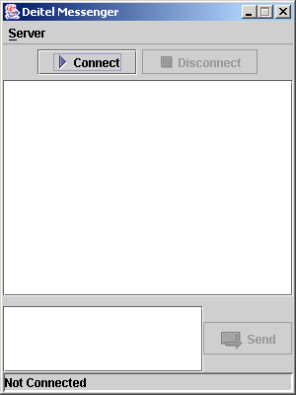
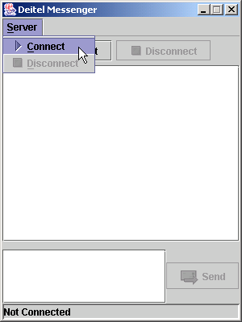
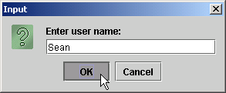

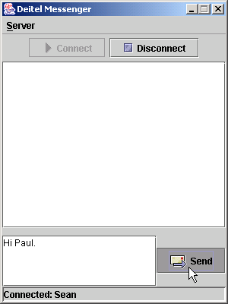

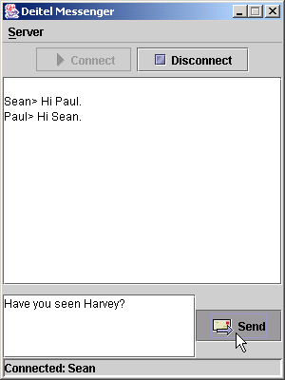
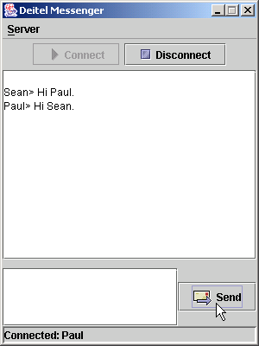

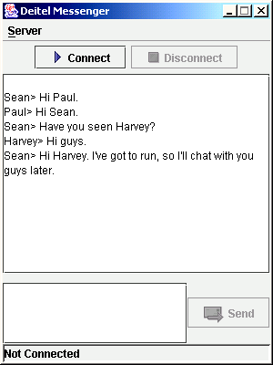
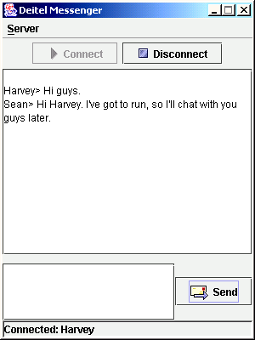
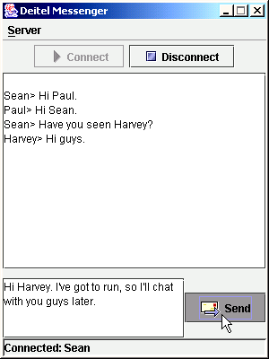

18.11 NIO Networking Overview

- Non-blocking I/O
- Readiness selection
  - Selectors
    - SelectableChannel
    - Selector

DeitelMessengerNonBlockingServer.java

1 // Fig. 18.22: DeitelMessengerNonBlockingServer.java
2 // Set up a nonblocking chatServer that will receive a connection from a
3 // client and echo client's message to all connected clients.
4 package com.deitel.messenger.sockets.server;
5
6 import java.io.*;
7 import java.nio.*;
8 import java.nio.channels.*;
9 import java.nio.channels.spi.*;
10 import java.nio.charset.*;
11 import java.net.*;
12 import java.util.*;
13 import java.awt.event.*;
14 import javax.swing.*;
15
16 public class DeitelMessengerNonBlockingServer extends JFrame {
17 private ServerSocketChannel serverSocketChannel;
18 private Selector selector;
19 private Vector sockets = new Vector();
20 private int counter = 0;
21 private JTextArea displayArea;
22 private Charset charSet;
23 private ByteBuffer writeBuffer;
24 private ByteBuffer readBuffer = ByteBuffer.allocate( 512 );
25
26 public DeitelMessengerNonBlockingServer()
27 {
28 super( "DeitelMessenger Server" );
29
30 displayArea = new JTextArea();
31 getContentPane().add( new JScrollPane( displayArea ) );
32
33 setSize( 200, 300 );
34 setVisible( true );
35
36 // close server socket channel and selector when closing window
37 addWindowListener(
38
39 new WindowAdapter() {
40
41 public void windowClosing( WindowEvent windowEvent )
42 {
43 // close server socket channel and selector
44 try {
45 serverSocketChannel.close();
46 selector.close();
47 }
48 catch( IOException ioException ) {
49 ioException.printStackTrace();
50 }
51 finally {
52 System.exit( 0 );
53 }
54 }
55
56 } // end inner class WindowAdapter
57
58 ); // end addWindowListener
59
60 } // end constructor
61
62 // set up and run server
63 public void runServer()
64 {
65 // set up server to receive connections; process connections
66 try {
67
68 // specify the char set used to encode/decode messages
69 charSet = Charset.forName( "UTF-8" );
70
71 // create a ServerSocketChannel
72 serverSocketChannel = ServerSocketChannel.open();
73 serverSocketChannel.socket().bind(
74 new InetSocketAddress( 12345 ) );
75 serverSocketChannel.configureBlocking( false );
76
77 // wait for a connection
78 getConnection();
79
80 } // end try
81
82 // process problems with I/O
83 catch ( Exception ioException ) {
84 ioException.printStackTrace();
85 }
86
87 } // end method runServer
88
89 // wait for connection to arrive, then display connection info
90 private void getConnection() throws Exception
91 {
92 // Selector for incoming requests
93 selector = SelectorProvider.provider().openSelector();
94 serverSocketChannel.register(
95 selector, SelectionKey.OP_ACCEPT, null );
96
97 // process incoming requests
98 while ( selector.select() > 0 ) {
99
100 // get channels ready for i/o
101 Set readyKeys = selector.selectedKeys();
102 Iterator iterator = readyKeys.iterator();
103
104 // for each ready channel, process request
105 while ( iterator.hasNext() ) {
106 SelectionKey key = ( SelectionKey )iterator.next();
107 iterator.remove();
108
109 if ( key.isAcceptable() ) { // ready for connection
110
111 // create connection
112 ServerSocketChannel nextReady =
113 ( ServerSocketChannel ) key.channel();
114 SocketChannel socketChannel = nextReady.accept();
115
116 if ( socketChannel != null ) {
117 socketChannel.configureBlocking( false );
118 sockets.add( socketChannel.socket() );
119 counter++;
120
121 SwingUtilities.invokeLater(
122
123 new Runnable() {
124
125 public void run()
126 {
127 displayArea.append(
128 "\nConnection with Client " + counter );
129 }
130 }
131 );
132
133 // register read operation to socketChannel
134 SelectionKey readKey = socketChannel.register(
135 selector, SelectionKey.OP_READ, null );
136
137 } // end if socketChannel != null
138
139 } // end if key.isAcceptable
140
141 else if ( key.isReadable() ) { // ready for read
142
143 // get socketChannel ready for read
144 SocketChannel socketChannel =
145 ( SocketChannel ) key.channel();
146
147 readMessage( socketChannel );
148 }
149
150 } // end processing each channel
151
152 } // end processing incoming requests
153
154 } // end method getConnection
155
156 // send message to client
157 private void writeMessage( String message ) throws IOException
158 {
159 Socket socket;
160 SocketChannel socketChannel;
161
162 // echo message back to all connected clients
163 for ( int i = 0; i < sockets.size(); i++ ) {
164 socket = ( Socket ) sockets.elementAt( i );
165 socketChannel = socket.getChannel();
166
167 // send message to client
168 try {
169
170 // convert message to bytes in charSet
171 writeBuffer = charSet.encode( message );
172
173 // write message to socketChannel
174 socketChannel.write( writeBuffer );
175 }
176
177 // process problems sending object
178 catch ( IOException ioException ) {
179 ioException.printStackTrace();
180 socketChannel.close();
181 sockets.remove( socket );
182 }
183
184 } // end for
185
186 } // end method writeMessage
187
188 // read message from client
189 private void readMessage( SocketChannel socketChannel )
190 throws IOException
191 {
192 // read message
193 try {
194
195 if ( socketChannel.isOpen() ) {
196 readBuffer.clear();
197 socketChannel.read( readBuffer );
198 readBuffer.flip();
199 CharBuffer charMessage = charSet.decode( readBuffer );
200 String message = charMessage.toString().trim();
201
202 // remove and close the connection when client disconnects
203 if ( message.indexOf( "Disconnect" ) >= 0 ) {
204 sockets.remove( socketChannel.socket() );
205 socketChannel.close();
206 }
207 else
208 writeMessage( message );
209
210 } // end if
211
212 } // end try
213
214 catch ( IOException ioException ) {
215 ioException.printStackTrace();
216 sockets.remove( socketChannel.socket() );
217 socketChannel.close();
218 }
219
220 } // end method readMessage
221
222 public static void main( String args[] )
223 {
224 DeitelMessengerNonBlockingServer application =
225 new DeitelMessengerNonBlockingServer();
226 application.runServer();
227 }
228
229 } // end class DeitelMessengerNonBlockingServer

SocketMessageManager2.java

1 // Fig. 18.23: SocketMessageManager2.java
2 // SocketMessageManager2 is a class for objects capable of managing
3 // communications with a message server.
4 package com.deitel.messenger.sockets.client;
5
6 import java.io.*;
7 import java.nio.*;
8 import java.nio.channels.*;
9 import java.nio.charset.*;
10 import java.net.*;
11 import java.util.*;
12
13 import com.deitel.messenger.*;
14
15 public class SocketMessageManager2 implements MessageManager {
16 private SocketChannel socketChannel;
17 private MessageListener messageListener;
18 private String serverAddress;
19 private ReceivingThread receiveMessage;
20 private boolean connected;
21 private Charset charSet = Charset.forName( "UTF-8" );
22 private ByteBuffer writeBuffer;
23 private ByteBuffer readBuffer = ByteBuffer.allocate( 512 );
24
25 public SocketMessageManager2( String host )
26 {
27 serverAddress = host;
28 connected = false;
29 }
30
31 // connect to message server and start receiving message
32 public void connect( MessageListener listener )
33 {
34 messageListener = listener;
35
36 // connect to server and start thread to receive message
37 try {
38
39 // create SocketChannel to make connection to server
40 socketChannel = SocketChannel.open();
41 socketChannel.connect( new InetSocketAddress(
42 InetAddress.getByName( serverAddress ), 12345 ) );
43
44 // start ReceivingThread to receive messages sent by server
45 receiveMessage = new ReceivingThread();
46 receiveMessage.start();
47
48 connected = true;
49 }
50 catch ( Exception exception ) {
51 exception.printStackTrace();
52 }
53 }
54
55 // disconnect from message server and stop receiving message
56 public void disconnect( MessageListener listener )
57 {
58 if ( connected ) {
59
60 // send disconnect request and stop receiving
61 try {
62 sendMessage( "", "Disconnect" );
63
64 connected = false;
65
66 // send interrupt signal to receiving thread
67 receiveMessage.interrupt();
68 }
69 catch ( Exception exception ) {
70 exception.printStackTrace();
71 }
72 }
73 }
74
75 // send message to message server
76 public void sendMessage( String userName, String messageBody )
77 {
78 String message = userName + "> " + messageBody;
79
80 // send message to server
81 try {
82 writeBuffer = charSet.encode( message );
83 socketChannel.write( writeBuffer );
84 }
85 catch ( IOException ioException ) {
86 ioException.printStackTrace();
87
88 try {
89 socketChannel.close();
90 }
91 catch ( IOException exception ) {
92 exception.printStackTrace();
93 }
94 }
95
96 } // end method sendMessage
97
98 public class ReceivingThread extends Thread
99 {
100 public void run()
101 {
102 int messageLength = 0;
103 String message = "";
104
105 // read messages until server close the connection
106 try {
107
108 // process messages sent from server
109 do {
110 readBuffer.clear();
111 socketChannel.read( readBuffer );
112 readBuffer.flip();
113 CharBuffer charMessage = charSet.decode( readBuffer );
114 message = charMessage.toString().trim();
115
116 // tokenize message to retrieve user name and message body
117 StringTokenizer tokenizer =
118 new StringTokenizer( message, ">" );
119
120 // ignore messages that do not contain a user
121 // name and message body
122 if ( tokenizer.countTokens() == 2 )
123
124 // send message to MessageListener
125 messageListener.messageReceived(
126 tokenizer.nextToken(), // user name
127 tokenizer.nextToken() ); // message body
128
129 } while ( true ); // keep receiving messages
130
131 } // end try
132
133 // catch problems reading from server
134 catch ( IOException ioException ) {
135 if ( ioException instanceof ClosedByInterruptException )
136 System.out.println( "socket channel closed" );
137 else {
138 ioException.printStackTrace();
139
140 try {
141 socketChannel.close();
142 System.out.println( "socket channel closed" );
143 }
144 catch ( IOException exception ) {
145 exception.printStackTrace();
146 }
147 }
148
149 } // end catch
150
151 } // end method run
152
153 } // end inner class ReceivingThread
154
155 } // end class SocketMessageManager2

DeitelMessenger2.java

1 // Fig. 18.24: DeitelMessenger2.java
2 // DeitelMessenger2 is a chat application that uses a ClientGUI
3 // to communicate with chat server.
4 package com.deitel.messenger.sockets.client;
5
6 import com.deitel.messenger.*;
7
8 public class DeitelMessenger2 {
9
10 public static void main( String args[] )
11 {
12 MessageManager messageManager;
13
14 // create new DeitelMessenger
15 if ( args.length == 0 )
16 messageManager = new SocketMessageManager2( "localhost" );
17 else
18 messageManager = new SocketMessageManager2( args[ 0 ] );
19
20 // create GUI for SocketMessageManager
21 ClientGUI clientGUI = new ClientGUI( messageManager );
22 clientGUI.setSize( 300, 400 );
23 clientGUI.setResizable( false );
24 clientGUI.setVisible( true );
25 }
26
27 } // end class DeitelMessenger2

18.12.1 Creational Design Patterns

- Abstract Factory design pattern
  - Creational design pattern
  - System determines subclass from which to instantiate objects at runtime
  - Uses a factory object
    - Uses an interface to instantiate object
  - Example:
    - java.net.SocketFactory creates SocketImpl object

18.12.2 Structural Design Patterns

- Decorator design pattern
  - Structural design pattern
  - Allows object to gain additional responsibilities dynamically
  - Example:
    - ObjectOutputStream writes objects to streams (bytes)
    - FileOutputStream writes bytes to files
    - We can “decorate” the FileOutputStream with ObjectOutputStream to write objects to files:
output = new ObjectOutputStream(
new FileOutputStream( fileName ) );

18.12.2 Structural Design Patterns

- Facade design pattern
  - Structural design pattern
  - Allows one object to represent a subsystem
  - Example:
    - Gas pedal is facade object for car’s acceleration subsystem
    - java.net.URL is a facade object
      - Can access InetAddress and URLStreamHandler objects through facade

18.12.3 Architectural Patterns

- Architectural patterns
  - Promote loose coupling among subsystems
  - Specify all subsystems and how they interact with each other

18.12.3 Architectural Patterns

- Model-View-Controller architectural pattern
  - Model
    - Contains application data
  - View
    - Graphical representation of model
  - Controller
    - Input-processing logic

Fig. 18.25 Model-View-Controller Architecture

notifies
modifies
Model
Controller
View

18.12.3 Architectural Patterns
- Layers architectural pattern
  - Divide system functionality into separate layers
    - Each layer contains a set of system responsibilities
    - Designers can modify layer without having to modify others
  - Example:
    - Three-tier architecture
      - Information tier maintains application data (via database)
      - Middle tier handles business logic
      - Client tier provides user interface

Fig. 18.26 Three-tier application model
Middle tier
Information tier
(Bottom tier)
(Client tier
Top tier)
Application
Database

